| Ousmane Toure & Jianning Chen  EECE2160 | Embedded Design: Enabling Robotics  Lab Assignment 7 |
| --- | --- |

Lab Assignment 7

Ousmane Toure & Jianning Chen

[Toure.o@northeastern.edu](mailto:Toure.o@northeastern.edu)

[chen.jiann@northeastern.edu](mailto:chen.jiann@northeastern.edu)

Submit date: 6/17/2022

Due Date: 6/17/2022

**7.1-7.2 Section 1 of Lab 7**

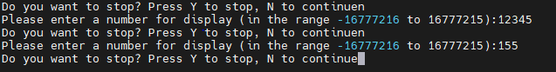

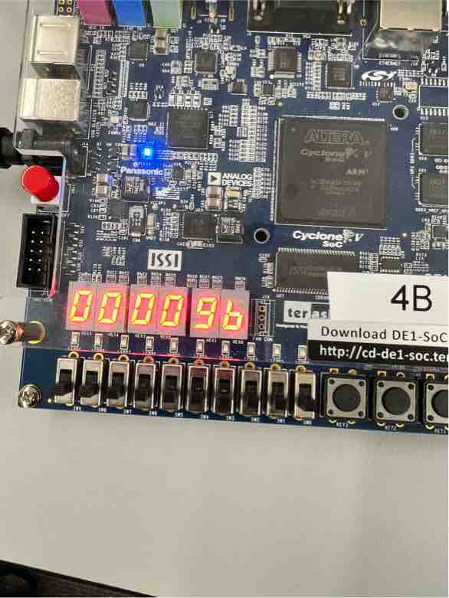

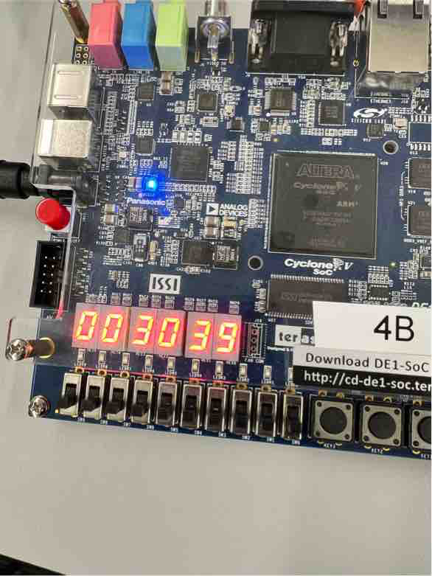

**7.3 Section 3 of Lab 7**

**7.3 code:**

DE1SoCfpga.h

#ifndef DE1SOCFPGA_H

#define DE1SOCFPGA_H

#include <stdio.h>

#include <unistd.h>

#include <stdlib.h>

#include <fcntl.h>

#include <sys/mman.h>

#include <iostream>

const unsigned int LW_BRIDGE_BASE = 0xFF200000;

const unsigned int FINAL_PHYSICAL_ADDRESS = 0xFFFEC700;

const unsigned int LW_BRIDGE_SPAN = FINAL_PHYSICAL_ADDRESS - LW_BRIDGE_BASE;

const unsigned int SW_OFFSET = 0xFF200040 - LW_BRIDGE_BASE;

class DE1SoCfpga{

protected:

char *pBase;

int fd;

public:

DE1SoCfpga();

~DE1SoCfpga();

//int ReadAllSwitches();

void RegisterWrite(unsigned int offset, unsigned int value);

int RegisterRead(unsigned int offset);

};

#endif //DE1SOCFPGA_H

DE1SoCfpga.cpp

#include "DE1SoCfpga.h"

DE1SoCfpga::DE1SoCfpga(){

fd = open("/dev/mem",(O_RDWR | O_SYNC));

if(fd == -1){

std::cout << "ERROR: could not open /dev/mem..." << std::endl;

exit(1);

}

char *virtual_base = (char *)mmap(NULL, LW_BRIDGE_SPAN,(PROT_READ | PROT_WRITE), MAP_SHARED, fd, LW_BRIDGE_BASE);

if(virtual_base == MAP_FAILED){

std::cout << "ERROR: mmap() failed..." << std::endl;

close(fd);

exit(1);

}

pBase = virtual_base;

}

DE1SoCfpga::~DE1SoCfpga() {

if(munmap(pBase,LW_BRIDGE_SPAN) != 0){

std::cout << "ERROR: munmap() failed..." << std::endl;

exit(1);

}

close(fd);

}

int DE1SoCfpga::RegisterRead(unsigned int offset) {

return *(volatile unsigned int *)(pBase + offset);

}

void DE1SoCfpga::RegisterWrite(unsigned int offset, unsigned int value) {

*(volatile unsigned int *)(pBase + offset) = value;

}

SevenSegment.h

#ifndef SEVENSEGMENT_H

#define SEVENSEGMENT_H

#include "DE1SoCfpga.h"

const unsigned int bit_values[16] = {0x3F,0x06,0x5B,0x4F,0x66,0x6D,0x7D,0x07, 0x7F,0x6F,0x77,0x7C,0x39,0x5E,0x79,0x71};

const unsigned int HEX3_0_OFFSET = 0xFF200020 - LW_BRIDGE_BASE;

const unsigned int HEX5_4_OFFSET = 0xFF200030 - LW_BRIDGE_BASE;

const unsigned int MPCORE_PRIV_TIMER_LOAD_OFFSET = 0xDEC600; // Points to LOAD

const unsigned int MPCORE_PRIV_TIMER_COUNTER_OFFSET = 0xDEC604; // Points to COUNTER

const unsigned int MPCORE_PRIV_TIMER_CONTROL_OFFSET = 0xDEC608; // Points to CONTROL

const unsigned int MPCORE_PRIV_TIMER_INTERRUPT_OFFSET = 0xDEC60C; // Points to INTERRUPT

const unsigned int letter_values[9] = {0x0E,0x5C,0x74,0x54,0x00,0x5E,0x5C,0x79,0x00};

class SevenSegment: public DE1SoCfpga{

public:

SevenSegment();

~SevenSegment();

void Hex_ClearAll();

void Hex_ClearSpecific(int index);

void Hex_WriteSpecific(int index, int value);

void Hex_WriteNumber(int number);

void Write_Letter(int index);

private:

unsigned int reg0_hexValue;

unsigned int reg1_hexValue;

int initialvalueLoadMPCore;

int initialvalueControlMPCore;

int initialvalueInterruptMPCore;

};

#endif //SEVENSEGMENT_H

SevenSegment.cpp

#include "SevenSegment.h"

SevenSegment::SevenSegment(){

reg0_hexValue = 0;

reg1_hexValue = 0;

RegisterWrite(HEX3_0_OFFSET,reg0_hexValue);

RegisterWrite(HEX5_4_OFFSET,reg1_hexValue);

initialvalueLoadMPCore = RegisterRead(MPCORE_PRIV_TIMER_LOAD_OFFSET);

initialvalueControlMPCore = RegisterRead(MPCORE_PRIV_TIMER_CONTROL_OFFSET);

initialvalueInterruptMPCore = RegisterRead(MPCORE_PRIV_TIMER_INTERRUPT_OFFSET);

}

SevenSegment::~SevenSegment() {

Hex_ClearAll();

RegisterWrite(MPCORE_PRIV_TIMER_LOAD_OFFSET, initialvalueLoadMPCore);

RegisterWrite(MPCORE_PRIV_TIMER_CONTROL_OFFSET, initialvalueControlMPCore);

RegisterWrite(MPCORE_PRIV_TIMER_INTERRUPT_OFFSET, initialvalueInterruptMPCore);

}

void SevenSegment::Hex_ClearAll() {

RegisterWrite(HEX3_0_OFFSET,0);

RegisterWrite(HEX5_4_OFFSET,0);

}

void SevenSegment::Hex_ClearSpecific(int index) {

if(index == 0){reg0_hexValue = reg0_hexValue & 0xFFFFFF00;}

else if(index == 1){reg0_hexValue = reg0_hexValue & 0xFFFF00FF;}

else if(index == 2){reg0_hexValue = reg0_hexValue & 0xFF00FFFF;}

else if(index == 3){reg0_hexValue = reg0_hexValue & 0x00FFFFFF;}

else if(index == 4){reg1_hexValue = reg1_hexValue & 0xFFFFFF00;}

else if(index == 5){reg1_hexValue = reg1_hexValue & 0xFFFF00FF;}

else{

std::cerr << "Index exceeding 5 or less than 0!" << std::endl;

exit(1);

}

}

void SevenSegment::Hex_WriteNumber(int number) {

int temp;

if(number >= 0) {temp = number;}

else {temp = 0xFFFFFF+number+1;}

temp = number;

int store[6] = {0,0,0,0,0,0};

int remainder;

int count = 0;

while(temp > 0){

remainder = temp%16;

store[count] = remainder;

count++;

temp = temp/16;

}

reg0_hexValue = 0;

reg1_hexValue = 0;

for(int i = 0; i < 6; i++){Hex_WriteSpecific(i,store[i]);}

}

void SevenSegment::Hex_WriteSpecific(int index, int value) {

Hex_ClearSpecific(index);

int temp;

temp = value;

if(index < 4){reg0_hexValue = reg0_hexValue | (bit_values[temp] << 8*index);}

else{reg1_hexValue = reg1_hexValue | (bit_values[temp] << 8*(index-4));}

RegisterWrite(HEX3_0_OFFSET,reg0_hexValue);

RegisterWrite(HEX5_4_OFFSET,reg1_hexValue);

}

void SevenSegment::Write_Letter(int index){

int temp_low = reg0_hexValue >> 24;

reg0_hexValue = reg0_hexValue << 8 | letter_values[index];

reg1_hexValue = reg1_hexValue << 8 | temp_low;

RegisterWrite(HEX3_0_OFFSET,reg0_hexValue);

RegisterWrite(HEX5_4_OFFSET,reg1_hexValue);

}

main.cpp

#include <iostream>

#include "SevenSegment.h"

int main(){

/*

SevenSegment *display = new SevenSegment;

std::cout << "Program Starting...!" << std::endl;

bool condition = true;

int hex_value;

while(condition){

std::cout << "Please enter a number for display (in the range -16777216 to 16777215):";

std::cin >> hex_value;

display->Hex_WriteNumber(hex_value);

std::cout << "Do you want to stop? ";

char v;

std::cin >> v;

if(v == 'y'){condition = false;}

}

std::cout << "Terminating...!" << std::endl;

delete display;

return 0;

*/

SevenSegment *display = new SevenSegment;

std::cout << "Program Starting...!" << std::endl;

int counter = 100000000; // timeout = 1/(200 MHz) x 200x10^6 = 1 sec

display->RegisterWrite(MPCORE_PRIV_TIMER_LOAD_OFFSET, counter);

display->RegisterWrite(MPCORE_PRIV_TIMER_CONTROL_OFFSET, 3);

int count = 0;

while(display->RegisterRead(SW_OFFSET)%2 == 0){

if(display -> RegisterRead(MPCORE_PRIV_TIMER_INTERRUPT_OFFSET) != 0){

display -> RegisterWrite(MPCORE_PRIV_TIMER_INTERRUPT_OFFSET,1);

display -> Write_Letter(count);

count++;

if(count == 9){count = 0;}

}

}

delete display;

std::cout << "Terminating...!" << std::endl;

return 0;

}

**Running Result**

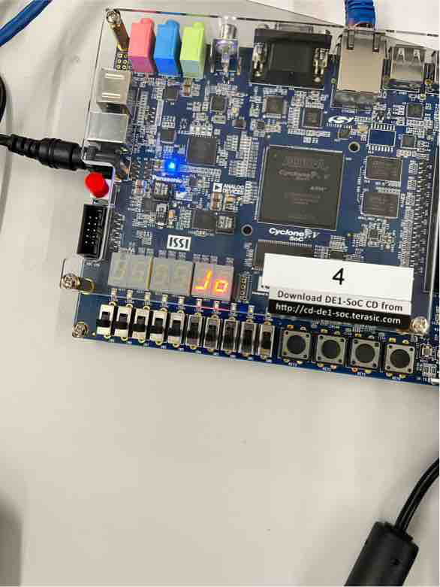

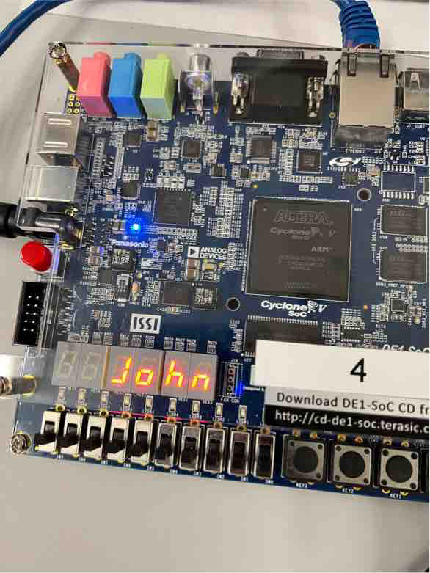

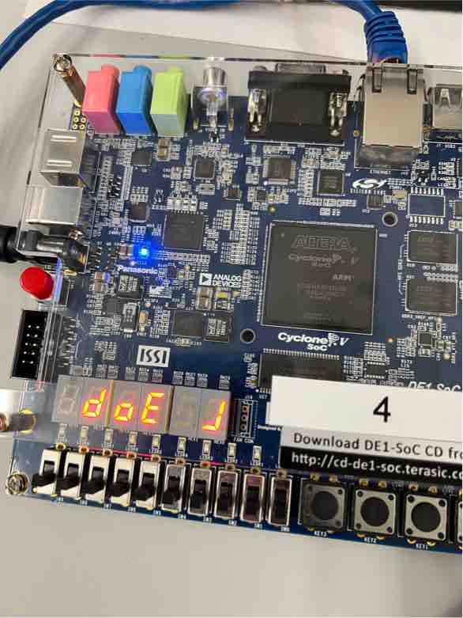

**Code Explanation**

In part 3 of the lab, the goal is to make a name rolling to the left using the timer of the DE1SoC board. Different from the prelab assignment where the seven-segment display is supposed to show numbers and letters from A to F, the name display is going to show “J”, “o”, “h”, “n”, “d”, “o”, “E” in order with space in between. Therefore, a new array is made that contains the corresponding hex value for these letters in 7-segment displays.

To make the letters roll to the left, simply change the timer load offset to 100000000 which means the timer will count every 0.5 seconds. After each 0.5 seconds, the while loop in the main.cpp will be called. In the seven-segment class, a member function is constructed, which shifts the hex value by 8 bits in order, and makes the decision to change the hex0value or the hex1value. The loop stops if switch 0 is turned on, this is done by register read.

# References

1. Prof. Julius Marpaung, “*Lab Report Guide*”, Northeastern University, January 6 2020.